Publicity Contact:
Karen Wyatt
970.470.2240
Kwyattmd@comcast.net

Author’s debut novel published in “a race against time”

ALL THE FLOWERS OF THE MOUNTAIN

By Christina Holbrook

Sunroom Studios | Publication Date: July 4, 2022

Sunroom Studios announces the upcoming release of author Christina Holbrook’s debut novel All the Flowers of the Mountain, which has received enthusiastic pre-publication reviews and comparisons to the writing of Nicholas Sparks and Delia Owens:
“Replete with the poignancy of Nicholas Sparks and the gritty authenticity of Delia Owens . . . a haunting, evocative exploration of the enduring power of love.”
–Emily Colin, New York Times bestselling author of The Memory Thief

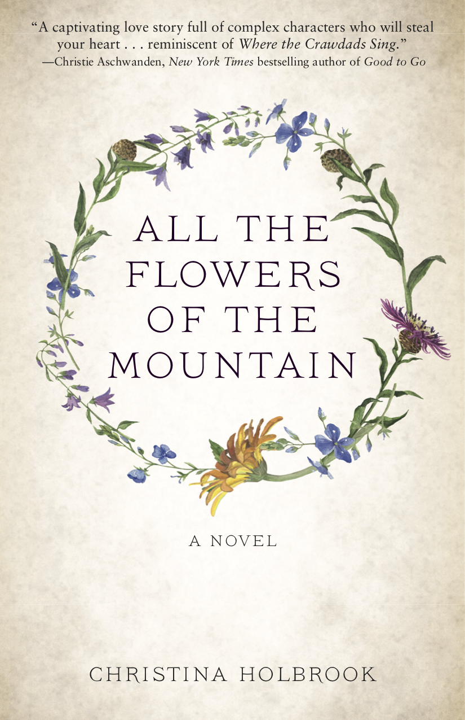
In a Paris art gallery, Dr. Michael Pearce is forced to confront his past when he views a sculpture by the artist Katherine Morgan. The vivid bronze artwork evokes memories of a summer many years ago, when Michael and Katherine–Kit–met as teenagers by a lake in New Hampshire. He was a small-town boy who skied, played guitar, and was destined to run his father’s hardware store; she was the restless, troubled daughter of a wealthy New York family.
Set amidst the mountains, farmlands, and elegant summer homes of rural New England, All the Flowers of the Mountain is the story of a pivotal summer for Michael and Kit. Michael’s ambitions are ignited by this young woman—he grows determined that their future will be together. But Kit dreams of becoming an artist and her struggle with a mysterious event from the past leads her to a deadly showdown by summer’s end, and decisions that will break Michael’s heart.
Holbrook captures the dark complexities of family secrets and the painful choices we face when the need to set our own course in the world opposes the demands of the heart. All the Flowers of the Mountain is a haunting exploration of trauma and the abuse of privilege, of desire and the enduring power of love.
“This book is a ‘love letter’ to New Hampshire,” says Holbrook, “a place where I spent such a transformative period of my life.” Jeff Deck, author of The Shadow Over Portsmouth series states: “Holbrook writes with such keen emotional awareness and descriptive flair that it is hard to believe Flowers is her debut novel. Wrapped in the lush but fleeting New Hampshire summertime, this evocative portrayal of longing and second chances is a gift not to be missed.”
New York Times bestselling author Christie Aschwanden adds: “Christina Holbrook’s gorgeous writing gives the book an intimacy and narrative momentum that makes it hard to put down. Holbrook’s novel will appeal to anyone who enjoys a story anchored in a strong sense of place.”
However there’s more to the story of All the Flowers of the Mountain. In March 2022 as Christina Holbrook began submitting her completed manuscript to publishers she was diagnosed with a brain tumor, which left the future uncertain for her and for her novel. Recognizing that time is of the essence, Sunroom Studios offered to accelerate the publication schedule so that no matter what happens she will see this book in print and in the hands of grateful readers. Both the novel and Holbrook’s personal story have won the hearts of the publishing crew, who have been honored to be part of this project.
All the Flowers of the Mountain reminds readers that despite trauma and loss and the uncertainties of life, love ultimately prevails—a message that is surely needed at this time.

ABOUT THE AUTHOR

A native of New York and the White Mountains of New Hampshire, CHRISTINA HOLBROOK now lives in Colorado with her husband, Alan Dulit. She received a Bachelor of Arts degree in French and Political Theory from Wellesley College. Holbrook’s column Lark Ascending ran in the Summit Daily in Frisco, Colorado, from 2016 through 2020. More recently, her short fiction and essays have appeared in numerous literary journals and anthologies. All the Flowers of the Mountain is her first novel.
For more background on the book and links to other works by the author, please visit www.christinaholbrook.com. Follow her on Instagram: @christinaholbrookwrites.

ABOUT THE BOOK

ALL THE FLOWERS OF THE MOUNTAIN By Christina Holbrook
Sunroom Studios | Publication Date: July 4, 2022 | Page Count: 388
Hardcover - 979-8-9861488-0-9 $31.95
Paperback - 979-8-9861488-1-6 $21.95

PRAISE FOR ALL THE FLOWERS OF THE MOUNTAIN

“Replete with the poignancy of Nicholas Sparks’s A Walk to Remember and the gritty authenticity of Delia Owens’s Where the Crawdads Sing, All The Flowers of the Mountain is a haunting, evocative exploration of the enduring power of love. Author Christina Holbrook skillfully combines a page-turning mystery, an insightful examination of social class, and a paean to one young woman’s insistence on being true to herself, no matter the odds...or the cost. If you’re anything like me, Kit and Michael’s story will resonate with you long after you turn the final page.”
--Emily Colin, New York Times bestselling author of The Memory Thief

“All the Flowers of the Mountain is a captivating love story full of complex characters who will steal your heart. Christina Holbrook’s gorgeous writing gives the book an intimacy and narrative momentum that make it hard to put down. The story’s tone is reminiscent of Where the Crawdads Sing by Delia Owens. Holbrook’s novel will appeal to anyone who enjoys a story anchored in a strong sense of place.”
--Christie Aschwanden, New York Times bestselling author of Good to Go, contributor to Outside Magazine, The New York Times, The Washington Post

“All the Flowers of the Mountain perfectly captures the thrill of young love and the bittersweet tang of roads not explored. Holbrook writes with such keen emotional awareness and descriptive flair that it is hard to believe Flowers is her debut novel. Wrapped in the lush but fleeting New Hampshire summertime, this evocative portrayal of longing and second chances is a gift not to be missed.”
--Jeff Deck, author of The Shadow Over Portsmouth series

“Right from the start, All the Flowers of the Mountain immerses the reader in a story of love and loss, hope peering around the corners of every page. The two main characters, Michael and Kit, are complex and multifaceted, demanding the reader’s attention and affection. There are many books that are easy to put down, but this is not one of them. Even after I finished the last page, I was reluctant to do so.”
--Caitlin Jans, founding editor of Authors Publish Magazine and co-founder of The Poetry Marathon
​

“All the Flowers of the Mountain is a love story that’s as humble as it is heroic. It’s a human story, one we all know, but live again through the timeless bond between Michael and Kit. It’s a story that invites us to laugh, cry, and sing with joy. And in the end, it’s a story that invites us home to ourselves, where all good love stories begin.”
--Ella Peary, Award-winning editor. Formerly Poetry Editor at Lumina, and currently columnist at Ruminate and best selling Finnish magazine, Ananda
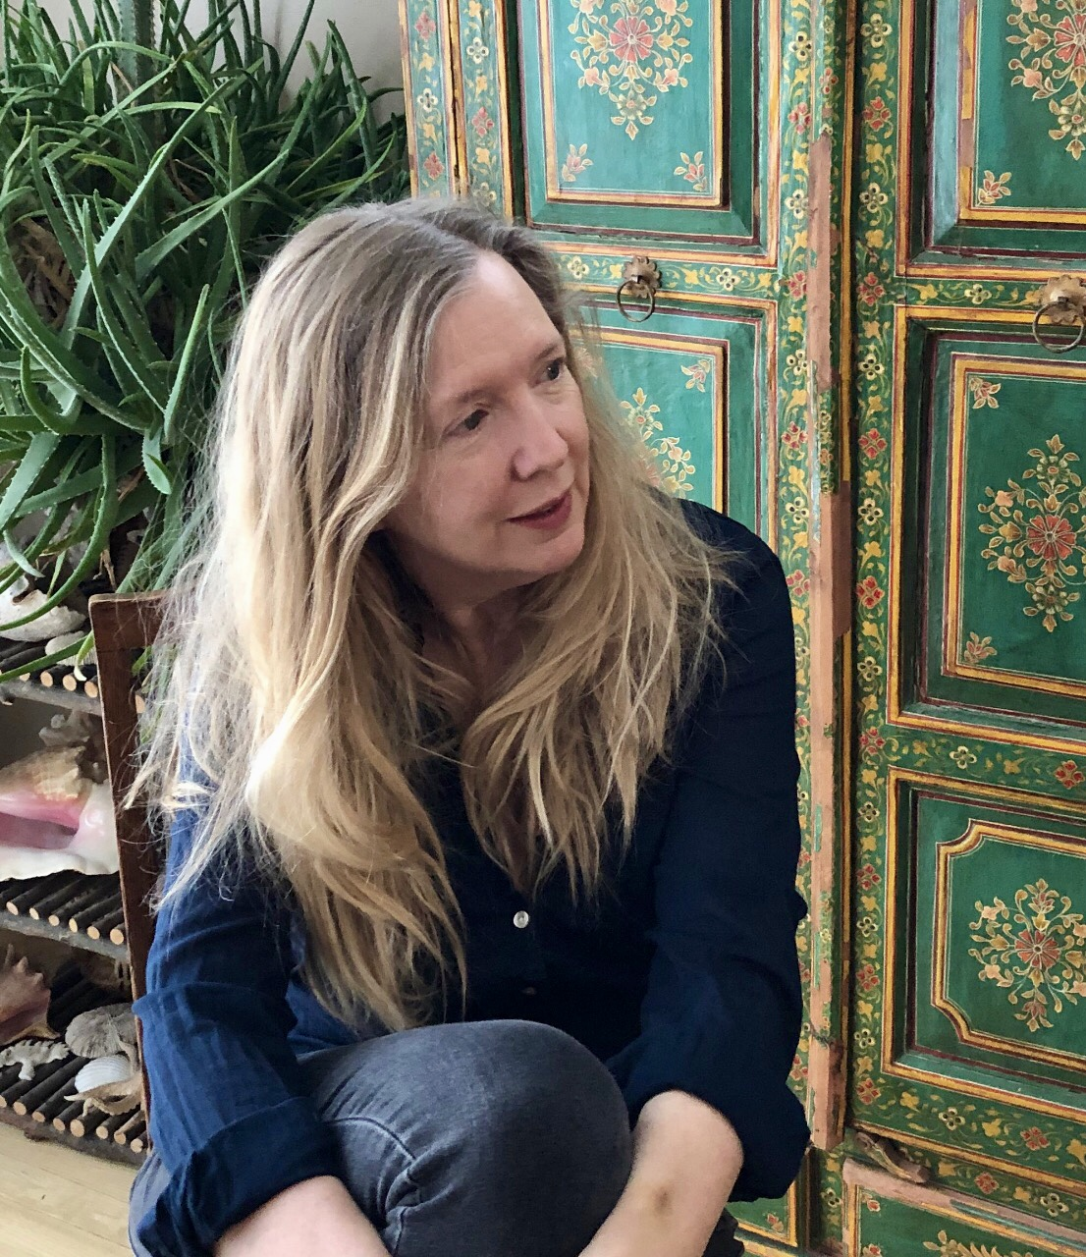
Q&A with
Christina Holbrook
author of

All the Flowers of the
Mountain

What is your debut novel All the Flowers of the Mountain about?
First and foremost it is a story about falling in love: About how one person can open your eyes, change your life, break your heart, and remain – despite time and distance – your North Star. The person you are always trying to get home to.

It is also a coming-of-age story, about the struggle to define who we are within the context of our family of origin; the hard choices we sometimes have to make, the mistakes and the loss, and how we find meaning in our lives.

Finally, for me, it is also a love song to a particular time and place. The White Mountains of New Hampshire, where I spent so much of my childhood, were (and still are) an absolutely magical part of the world. And the 1970s and early 80s were a time of unusual freedom—there were no cell phones, and there was still a great deal of emotional distance and lack of supervision in the relationships young people had with their parents. This freedom opened the door to both danger and exciting possibilities.
Rural New Hampshire plays an important role in the story. Why did you choose it as the setting for your novel?
I grew up spending summers in the White Mountains. My family had a beautiful, rambling country home in Sugar Hill, New Hampshire, and my mother’s parents also had several farm properties in different locations.

I think my inner, personal and creative landscape was formed in this place: swimming in Echo Lake or in the icy pools below the waterfalls at The Basin, climbing Mount Lafayette, skiing Cannon Mountain, spending entire days exploring on my bike. And like Kit, I was a big fan of skinny- dipping!

My school year was spent in New York, so it was tremendously liberating to be set free in this wild, rural place where time was so unstructured. I could easily spend an entire day sitting very still and hoping to catch a glimpse of deer or fox in the woods, searching for hidden swimming holes, or laying back in the field grass watching clouds float through the sky—and not encounter another living soul.

As a kid, I was also always trying to make sense of a kind of spiritual reality I was aware of. I felt this very strongly in the wild places of my childhood. I remember being quite convinced, one early morning, that as I came down a path through the woods, I was about to encounter God!

Finally, those years when I was a child and then a young woman in New Hampshire were very meaningful to my family. Together we experienced an awful lot of fun, drama, and rich memorable times.
What are the challenges of writing about actual locations and businesses in your book compared to creating fictional settings?
Many of the important locations in the story are in fact made up. Having spent so many years in the White Mountains it was somehow easy for my imagination to concoct the particularly grand summer house and farm that is “Cedaredge,” the Morgan family compound. And while Profile Lake is an actual lake, the Profile Lake Club is a fabrication as is the “wild side” of the lake where Kit and Michael make some important discoveries related to the story’s key mystery.

That being said, no story about this area would be complete, would be authentic to the reader, without the inclusion of some of the most beloved landmarks: Polly’s Pancake Parlor (where, by the way, I worked one summer!), The Sugar Hill Sampler, Thayer’s Hotel which once included a pub called “Oliver’s.” There is an elegant Profile Club, though it is not on the lake, and the Old Man of the Mountain, an iconic rock formation, sadly tumbled from the mountain several years ago.

When I do refer to real places, I try to capture the essence of their charm or glamour. But they are fictional creations of my own, and their details are not necessarily accurate in a journalistic sense. It is my hope that those connected to these places will forgive any errors and my flights of fancy.
Kit and Michael grew up in very different social and economic circumstances, which proved to be an obstacle in their relationship. Why did you feel this was an important issue to explore in the novel?
My feeling is that families of origin are often on the side of safety; parents want their children to live the same kind of lives they have lived.
Families have a way of exerting pressure on the younger members to perceive the world through the same lens as the family elders. In the best cases, parents do this because they want their children to be happy; in less- than-ideal cases they don’t want their views of the world challenged by their children’s choices.

I came from an “old family,” like Kit – relatives on my father’s side of the family arrived in this country on the Mayflower and fought in the American Revolution. I was a debutante, as were other women on both sides of my family. So, I am familiar with the particular kind of pressure to make choices that would affirm, for the older generation, the values of this social group.

But demands can be exerted in many ways. Michael’s family objects to Kit, just as Kit’s family looks down on Michael. His family do not want him to stretch himself, to seek more education—they would prefer he stay home and reaffirm the values of his parents. In that way, his family is as rigid as Kit’s.

I think it is a weakness, a kind of selfishness and short-sightedness, that many adults show when they put pressure on their kids or the younger generation to perceive the world the way they do – this may have to do with class and economics, but it can also just as easily be about race, religion, politics, professional choices, gender or sexual preferences.

While there is a specific social/economic conflict in this story, I hope readers might find a kind of universal aspect, too – as in the tale of “The Ugly Duckling.” Both Kit and Michael experience the pain and confusion of being outsiders within their own families—and part of each of their individual journeys is to discover who they are and find their true place in the world, and their tribe. That journey is one that life urges on each of us, no matter who we are or where we come from.
Both Kit and Michael want to figure out what will make life meaningful for them. What do you think it takes to create a life of meaning? What might we have to give up in order to find greater meaning?
Both Michael and Kit have to confront family and social situations in which others presume to know what is best for them, what they should want. And society has only become more insistent, more in- your-face in this regard.

For Kit, the pressure is so intense that she believes her only option is to take drastic and dramatic action. To forfeit love. Michael has to find a way to create meaning in his life, even when love seems lost forever.

It can take a long time to grow up, and so I believe that their time of separation is necessary. You have to make a lot of mistakes, confront your demons, be ready to put your ego aside so that one day you are both strong enough and vulnerable enough to humble yourself to love.

As I get older it is more and more clear to me that, in the end, love is all that matters. It’s so simple, but it can take a lifetime to figure this out.
Michael and Kit share a connection to and love for the natural environment of New Hampshire. What does a connection to nature mean for you, personally?
I think a connection to nature is what grounds us and makes us feel alive. Kit regains a sense of herself as a whole person – creative, sensual, hopeful, and self-confident – during her summers exploring the forests, lakes, waterfalls, mountains of New Hampshire.

When Michael wants to share with Kit who he really is, he takes her on a hike up a hillside to experience a view of all the surrounding mountains and farmlands, rivers and forests of his New Hampshire home. And, ultimately, both return to this place of deep and intimate natural beauty.

Also, as time went on, and I made more revisions to the story, I began to make this connection between Kit and the Cedaredge bull, Freddie. Both are unfairly penned in, and both ultimately make a break for it.
Why did you choose to structure the novel with present time events as bookends around a major flashback to many years in the past?
Good question, because earlier drafts of this novel take place only when Kit and Michael are young. But I knew somehow that they would come back to each other —they had to!—and that each would be changed by the intervening years. I suppose I understood that Kit and Michael had their own life lessons to learn, and that they had to do that learning on their own. But ultimately, they were meant to be together.
You’ve been working on this book for five years now including
many revisions and challenges along the way. What has your writing process been like and how has it been influenced by your own personal journey?
It’s been a long process! The novel began in the first person as a story told by Michael. Then, I re-wrote the story in the third person. Finally, I spent a year on this final version, re-writing the novel so that it would include both Kit’s and Michael’s points of view.

What seemed curious to me from the start is that I felt completely driven to work on this manuscript, every day without fail. I didn’t procrastinate, had no issues with writer’s block, but was up at 4:30 or 5 am each morning and writing until I could barely see. It was like an obsession—and it only became more intense in the past year, as Kit began to tell her side of the story.

In March, just as I was about to begin submitting the manuscript to publishers, I was diagnosed with a brain tumor. It sounds crazy, but I can’t help wondering now if some part of me “knew” that I was running out of time.

I had surgery in April and will begin treatment soon. I hope and pray that I still have plenty of months and years ahead of me. But the truth is I don’t know. I received an amazing gift when Sunroom Studios offered to bring this novel out in what amounts to lightning speed, with a pub date in July! Because I want to hold this book in my hands.
Like a good fairy tale, this story seems to be populated with a cast of supporting characters: some who help the main characters and others who threaten them. Tell us about some of these.
One of my very good readers, Jeff Deck of the New Hampshire Writers Project, urged me to think about my secondary characters and to develop them as much as possible.
Kit and Michael are both compelled to seek different paths from the ones their families would have liked. They are each determined to confront and experience life on their own terms—mistakes, suffering and all. Along the way, both Michael and Kit meet villains who threaten them, and mentors and guides who help them grow, gain clarity, and transform as human beings.

Kit’s extended family threatens Kit’s and Michael’s happiness and stirs up trouble and creates confusion. Fortunately, Michael has his good friend Tom to lean on. And his boss the veterinarian John Landsman bolsters his confidence by trusting him with tough work assignments and relating to him man-to-man. Alfred the hermit appears like a friendly spirit offering help and clues. Elsie and Max gently encourage Kit to see herself more clearly, and of course Esther Winthrop emerges as a kind of fairy-godmother. And at two crucial moments, Kit’s little sister and brother each save the day.
The novel explores womanhood and various challenges faced by women in our society as one of its themes. Why is this important to you? In what way is Kit a reflection of your own journey?
What’s funny is that the very first draft of this novel, begun five years ago now, was written in the first person, from Michael’s point of view only! I strongly identified with his character—and still do.

Many re-writes later, I had a conversation with the novelist Emily Colin. She urged me to expand the story so that it included Kit’s point of view as well. I resisted at first, and now it seems, well, pretty obvious that this story had to be a weaving back and forth between both characters. Did I resist this because Kit’s point of view was necessarily so much more personal? So much harder? Probably.

In a certain way, Michael is a much more straight-forward character. And maybe our society creates the conditions for boys and men to operate in the world in a more straight-forward manner. For women, it’s different. And particularly during the period when much of this story takes place, say, in the late 1970’s-early 1980s. Opportunities were opening up for women, but at the same time women were still expected to conform and acquiesce to men. And my experience at least was that women were encouraged to have “interests” but when interests turned to focused ambition that was perceived as anything from unattractive to downright dangerous.

Kit journeys from naive and vulnerable— uncertain if she can trust her own instincts —to strong, self-aware and sure of her place in the world. I can relate to traveling this long and at times arduous path. And Michael also journeys to a place of confidence in the world. Kit and Michael become emotionally whole when they are finally able to admit that their lives will not be complete without the other and when they both are ready to take action to address this need.

Finally, this story has a personal layer for me. As a young woman I had a very close friend named Alan. We hiked and did homework together, spent hours talking on the phone, and stumbled through awkward flirtation. Eventually Alan moved out west, and I made a life on the east coast. It took me 35 years, and several bungled opportunities, to realize that this was the person who I had been missing all my life. We were married in 2018.

ALL THE FLOWERS OF THE MOUNTAIN

By Christina Holbrook
Sunroom Studios
Publication Date: July 4, 2022
Page Count: 388
Hardcover - 979-8-9861488-0-9 $31.95
Paperback - 979-8-9861488-1-6 $21.95

Hardcover Now Available for Pre-Order at
Barnesandnoble.com

